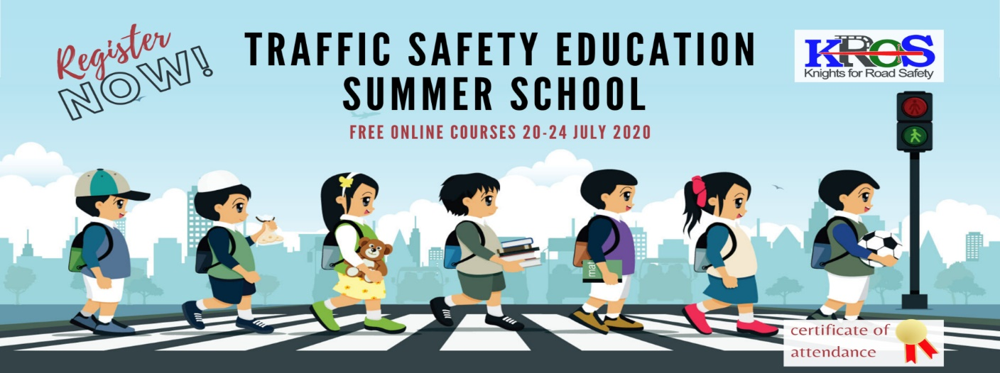

PRESS RELEASE

1st European Traffic Safety Education
Virtual Summer School

The Road Safety Institute (RSI) "PANOS MYLONAS" in collaboration with Ellinogermaniki Agogi Schools organizes the 1st European Traffic Safety Education Virtual Summer School for teachers. The webinar, which will last from 20 to 24 July, takes place in the context of the EU co funded ERASMUS+ program "KROS: Knights for ROad Safety", which aims to strengthen the professional profile of teachers, by improving their knowledge and skills on road Traffic Safety and Mobility Education. The Summer School will address topics such as the integration of Road Safety in the school curricula, road safety topics specifically for the age groups of children and adolescents, 21st century skills and digital literacy in traffic safety education, STEM activities, as well as the use of the tools and resources developed in the KROS project (virtual reality scenarios, activity sheets, and suggested lesson plans).

Experts from schools and acknowledged organizations in the field of education and traffic safety from all over Europe, such as the Department of Educational Radio-television and Digital Media of the Greek Ministry of Education and Religious affairs, Trinity College of Dublin, the Polish Institute of Transport and OMEGA Technology will present their good practices. The KROS project involves a network of pilot schools from all over Europe for the exchange of good practices and innovation on traffic safety education (KA2 - Cooperation for innovation and exchange of good practices: Strategic Partnerships in the field of school education - National Coordination Unit IKY)
- Working language of the seminar is English.
- Upon successful completion, a certificate of attendance is given to all participants.
- More info at: http://esia.ea.gr/training/knights-for-road-safety
tel.: +30 2108620150 email: krosproject@ioas.gr

